To create a medication re-order list and reminder, we are going to use the “Reminders” function in Jointly, to set up first a reminder, and then a list of items associated with this, that will prompted us after a set number of days to action the list again, and again, as we decide.
To set this up, first lets – head to “Reminders”
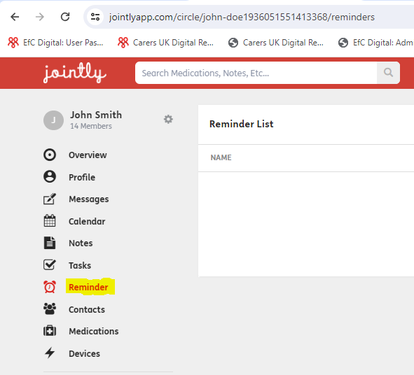

Step two – now let’s create a new reminder list:
Select “add reminder”

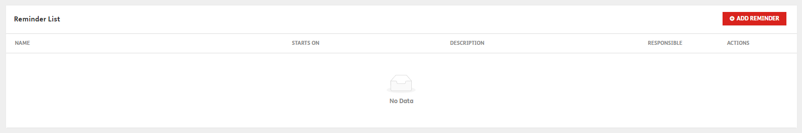

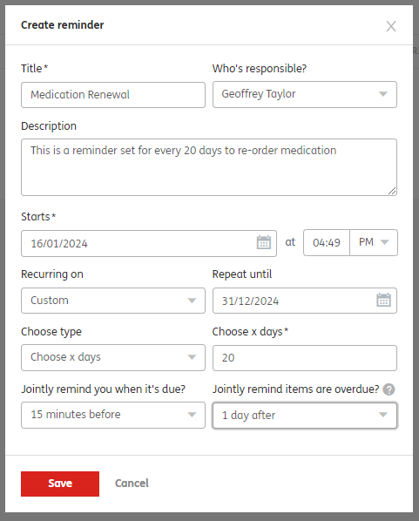 | Here we have given our reminder list a title “Medication Renewal” – we have said who in the circle of care is responsible for actioning (in this case me), we have given our reminder a description, we have said the start date of our reminder (and time), we have chosen “custom” as our recurring period, and said for this reminder to come around again every 20 days. Lastly we have said that a push notification will go to the person responsible for the reminder to be actioned, 15 mins before it is due, and that a further reminder will be pushed to them 1 day after due, if not actioned. With all this in place we save our reminder.

Now we have our reminder list in place, we can choose what medication we want to be reminded about re-ordering.
We do this by clicking any where on the reminder list to open it up and add items:
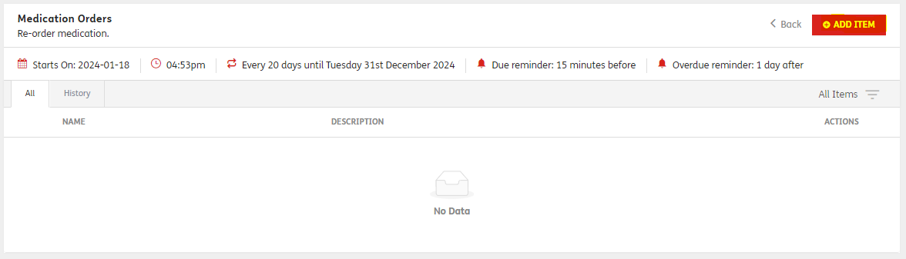

Clicking on “Add Item” we can add in our medications:
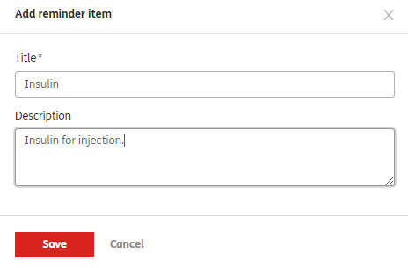

We can do this over and over again, saving each medication we wish to have on our remind to order list.
As we add each item, it will appear on our reminder list:
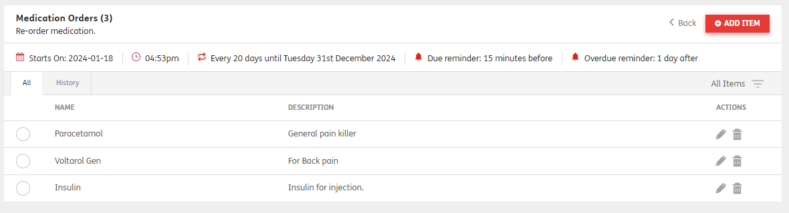
We can see at the top, when this reminder starts, and how often it is repeated – until what date. We can also see the notifications we have set to receive.
Our reminder list is now complete, and as of the start date we will now receive push notifications to remind us to order our items.
When actioning this reminder, we open our list, and tick against each item, denoting it has been ordered:
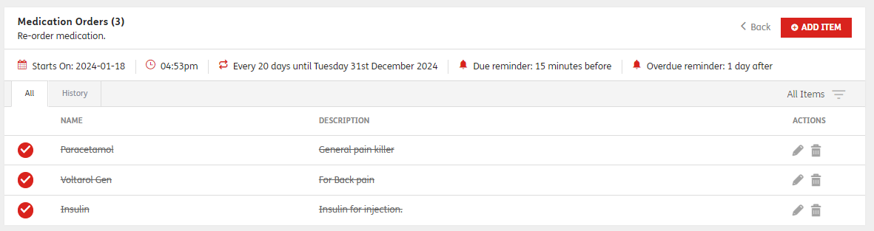
When we go to our History tab, we can see each of these items actioned, when and by whom, so we have a clear audit trail:
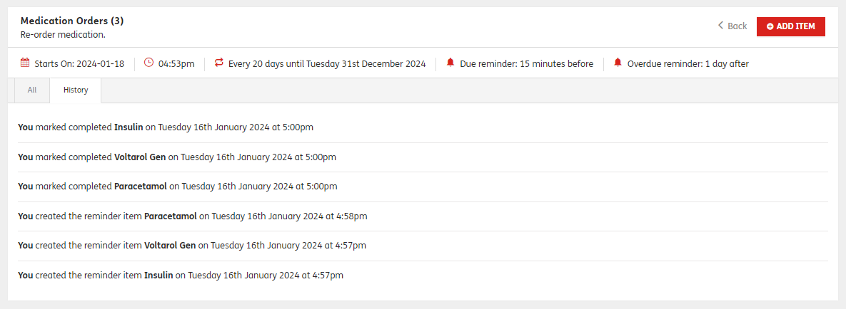
In this example, with our reminder list actioned, it will now remain dormant for the next 20 days as we have defined, only becoming active when next due again – at this point, the user can action each item again, and so on.

